Morning,

Quick look at the numbers, which are trending slightly down from last week, but we are looking at a strong end of the month with freelancers now onboarded and less admin to do.

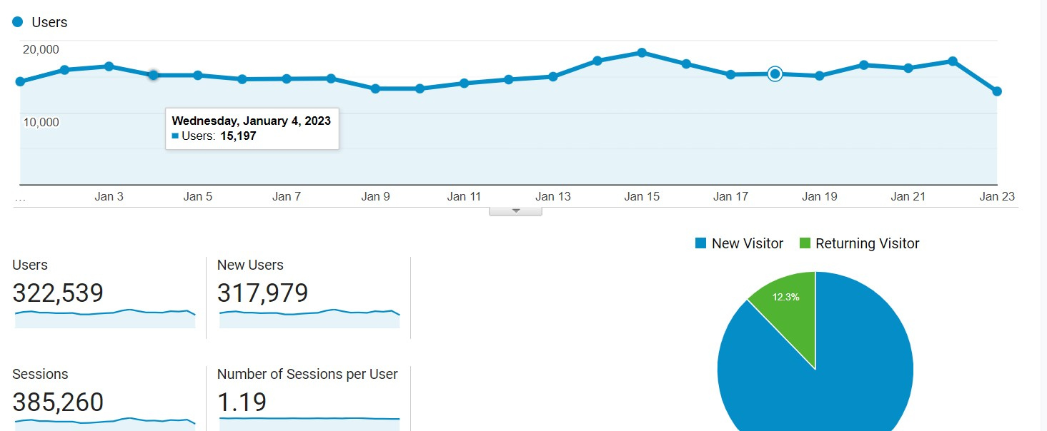

We are trending towards 430k+, sessions also look up.

Traffic Development 2022.xlsx

Goals 2023.xlsx

Team expansion

Alvaro and Zach have begun producing pieces, they will work on Genshin Impact, and one of them will take the lead on Omega Strikers will it launches early next month.

Hritiwk has issues with his email, will investigate today and sort.

MobileMatters style guide (WIP)

Content

More Redeem code stories.

We should take note that we are entering Chinese/Lunar New Year. Many of the mobile titles we cover - and don’t - are developed and published by Chinese companies.

Big updates and releases are thin on the ground over the next few weeks. But that will change by the end of Feb.

Wednesday:
- Rocket League Sideswipe Season 7
- Wild Rift F2p
- Marvel Snap Weekly
- Free Fire Weekly Schedule

Friday:
- Asphalt 9

Videos

This week will be dedicated to the top 5 plays from each week of the SPS Challenge Season 2 EU & MENA tournament for Wild Rift.

Social Media

Facebook performed well in the previous week. Leo had slightly increased the budget for paid marketing and that’s evident in the extra million in overall reach compared to last week.

Naturally, with more eyeballs on the pieces, we saw better
post engagement and an increase to our follower count.

The slight decrease in organic reach could be attributed to the slow news week we had. Besides the version 3.4 update in Genshin Impact, all was mostly quiet on the news front (push content that usually thrives on SM).
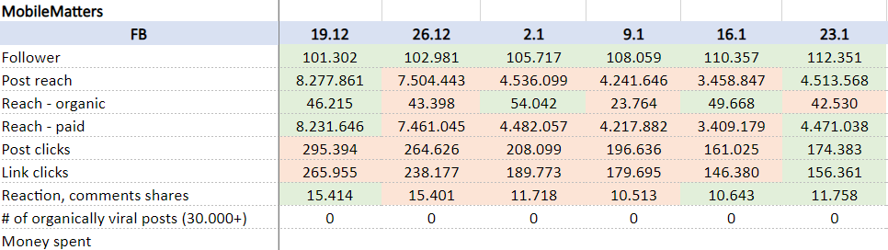
Nothing too major to report for Instagram. Our page benefited from the paid marketing on FB, so that’s the main reason we saw a large increment in the numbers across most of the KPIs.
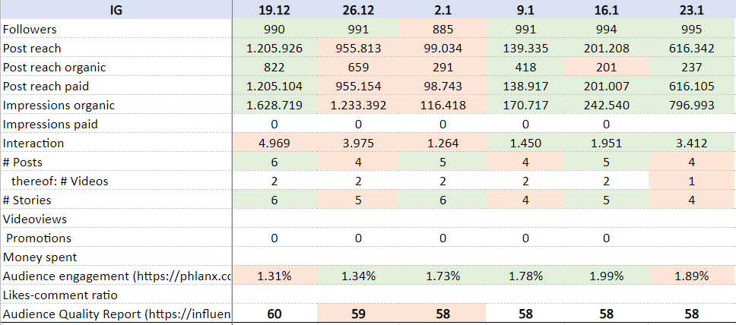

Snippet of our views and subscribers on the MM YouTube page:

